# Veritaseum Token Tutorial

In order to use anything on the Ethereum network a person needs to have an Ethereum account. The easiest way to do this, is with [MyEtherWallet](http://www.myetherwallet.com/)

## Generate an Ethereum Account

### Step 1

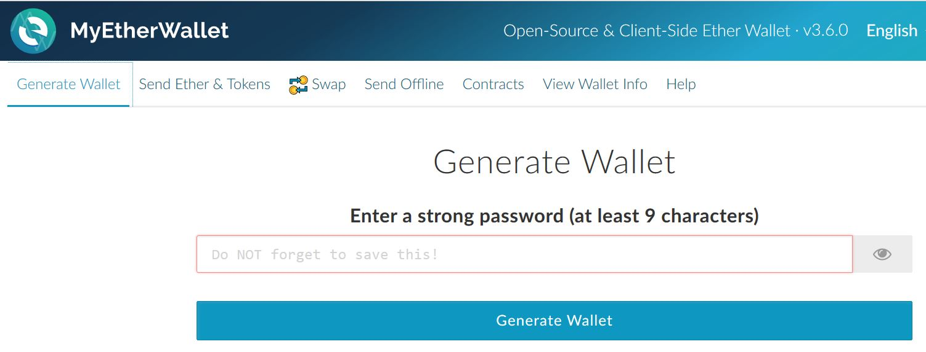Click on Generate Wallet and enter a good password. You will always be able to regenerate the same account from the same password.

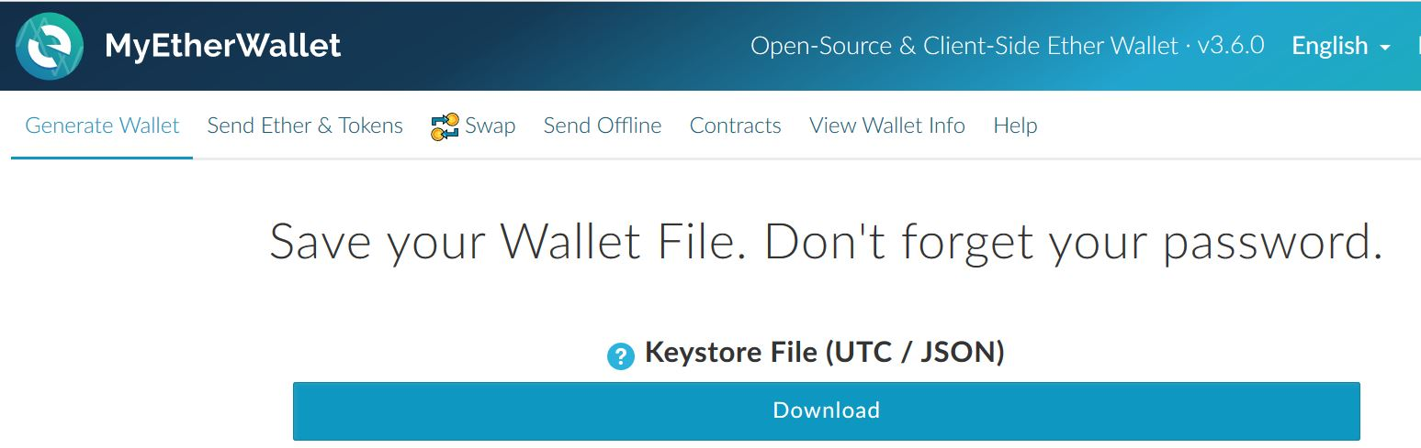

Click download and save the **json** file **BUT** keep this file safe and private. Any person who gets their hands on this file can now access your account, so store it safely.

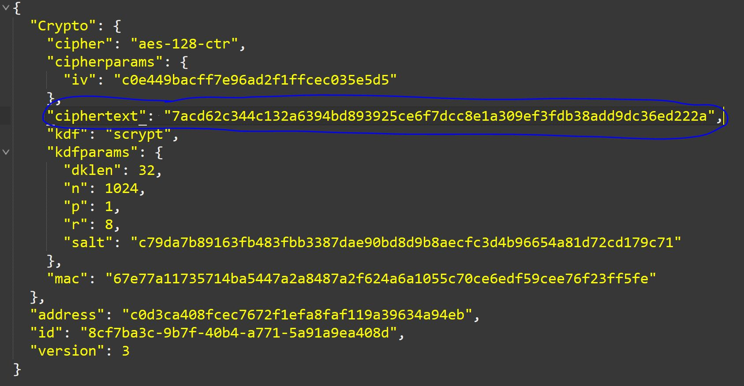Open the file and look at **ciphertext.** This value is your private key. This private key is the part that MUST be kept secret.

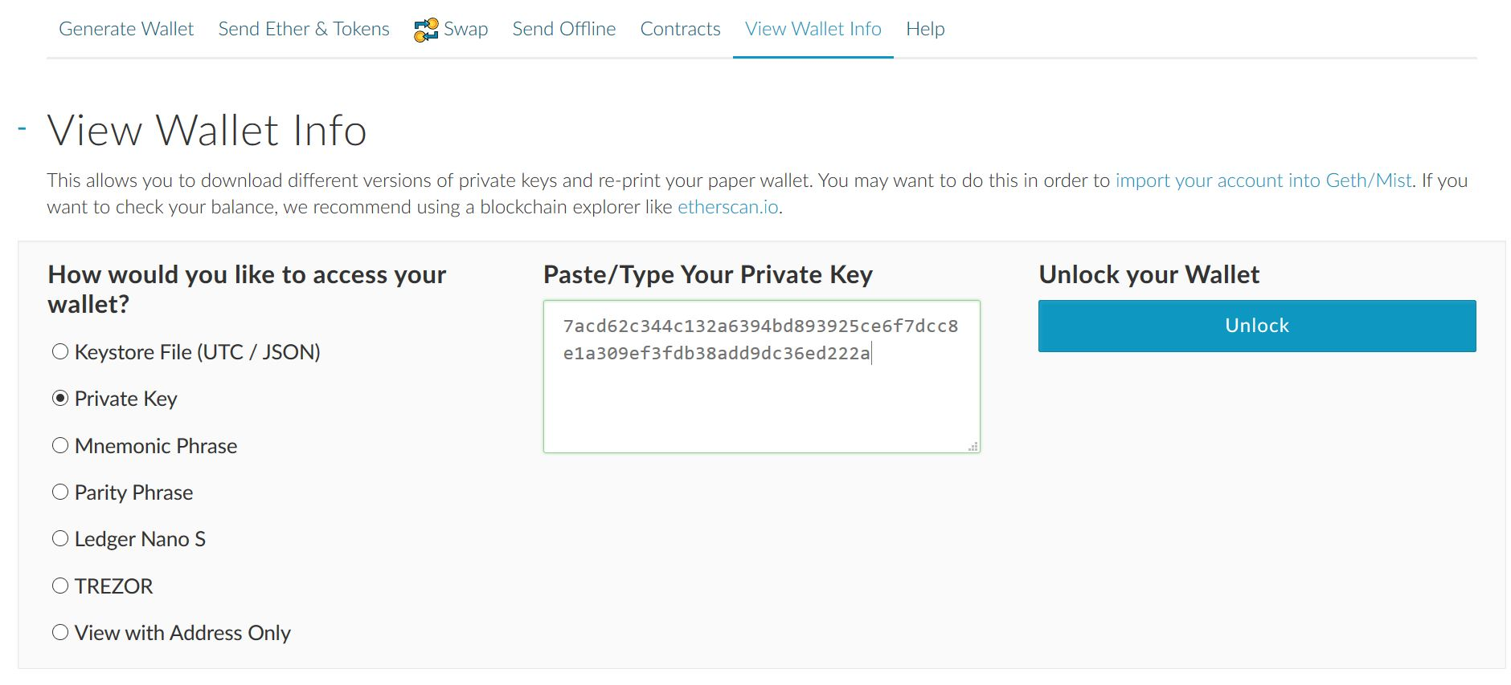Copy this **ciphertext/private key** into memory and go to the **View Wallet Info** tab at the top of the page.

Select the Private Key radio button and paste your private key into the box. **Click Unlock.**

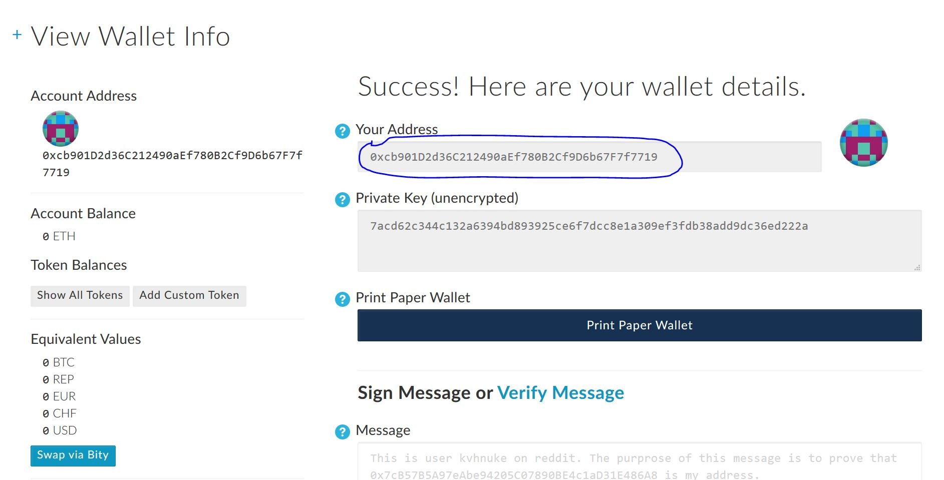Now you can access your Ethereum account! It is here that you will find your Ethereum address, view the balance that this account has in it, view any tokens that it has, and other interesting things also.

## Get Ether

As you can see, new accounts do not hold any Ether and you will have to get some.

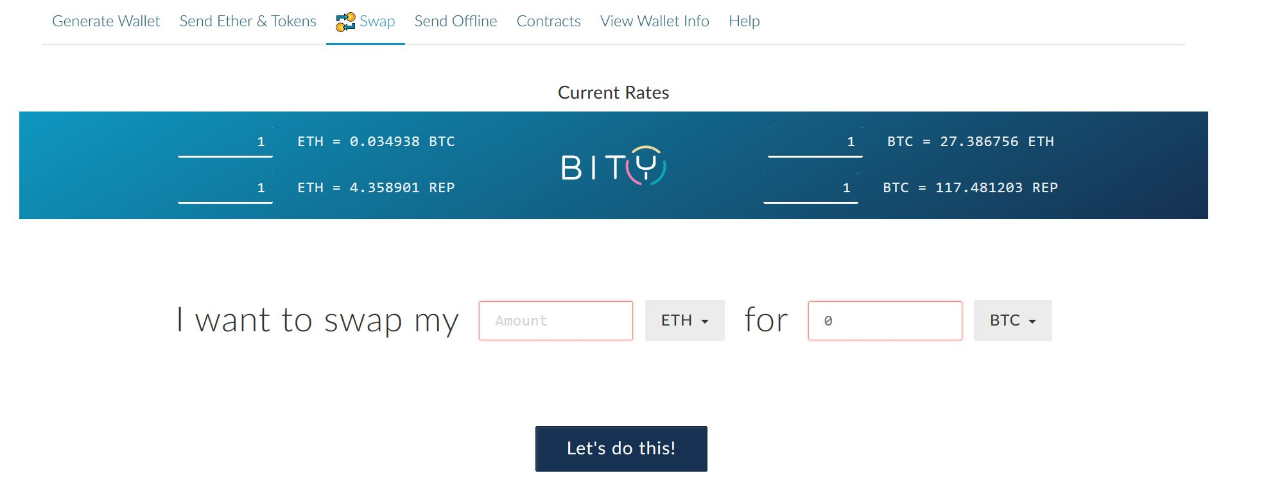Click on the **Swap** tab at the top of the page to exchange your bitcoins for Ether. Alternatively you may use [ShapeShift](http://shapeshift.io/)

## Exchange for VERI Tokens

Once you have some Ether, you are ready to exchange those Ether for **Veritaseum Tokens!**  One VERI Token costs 0.03333333333 Ether, so for one Ether you get 30 VERI Tokens!

The ICO crowdfunding stage is from **2017 April 25th 9:30 EST (14:30 UTC)** and lasts for 31 days. There is even a 20% discount for tokens purchased on day one (after the start), a 10% discount for tokens purchased on day two (after the start), and every consecutive day the discounted rate will reduce by 1% per day until the normal price is reached (day 12)!

The VeritaseumToken smart contract is an Ethereum ERC20 compliant token, which means that you can exchange VERI tokens on any Ethereum based exchange.

The address of the VeritaseumToken is at: **0x8f3470a7388c05ee4e7af3d01d8c722b0ff52374**

**The source code of the** VeritaseumToken can be found at: <https://github.com/RFVenter/Veritaseum/blob/master/contracts/VeritaseumToken.sol>

To purchase VERI tokens during the ICO phase you will have to use another smart contract which has been designed to sell tokens at the correct price during this time.

The address of the TokenPurchase is at: **0x599a4b8188676224d4c9b393b947e332b60b15e3**

**The source code of the** TokenPurchase can be found at:

<https://github.com/RFVenter/Veritaseum/blob/master/contracts/TokenPurchase.sol>

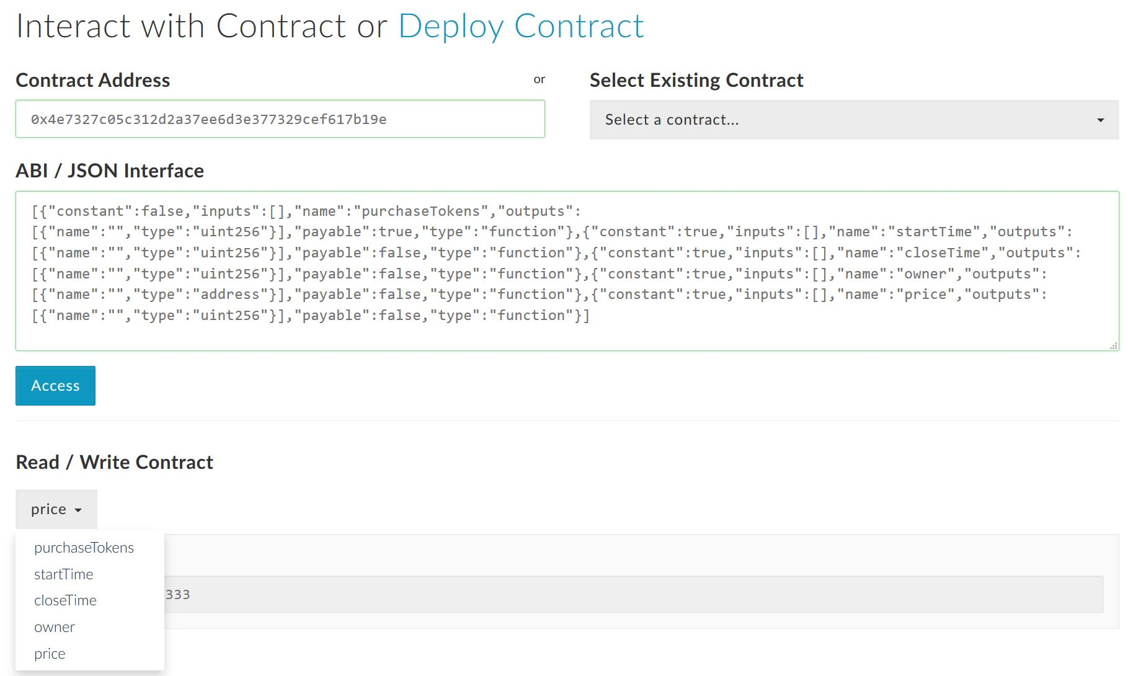

Click on the **Interact with Contract** tab at the top of the page. Enter Contract address **0x599a4b8188676224d4c9b393b947e332b60b15e3.**

**Copy and paste** the TokenPurchase ABI code from the box below:

|  |
| --- |
| [{"constant":false,"inputs":[],"name":"purchaseTokens","outputs":[{"name":"","type":"uint256"}],"payable":true,"type":"function"},{"constant":true,"inputs":[],"name":"startTime","outputs":[{"name":"","type":"uint256"}],"payable":false,"type":"function"},{"constant":true,"inputs":[],"name":"closeTime","outputs":[{"name":"","type":"uint256"}],"payable":false,"type":"function"},{"constant":true,"inputs":[],"name":"owner","outputs":[{"name":"","type":"address"}],"payable":false,"type":"function"},{"constant":true,"inputs":[],"name":"price","outputs":[{"name":"","type":"uint256"}],"payable":false,"type":"function"}] |

*If the site asks you again, then enter your private key again and* ***Unlock****.*

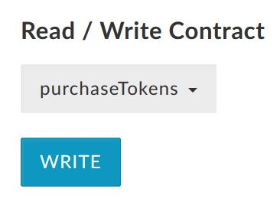

Click **WRITE**

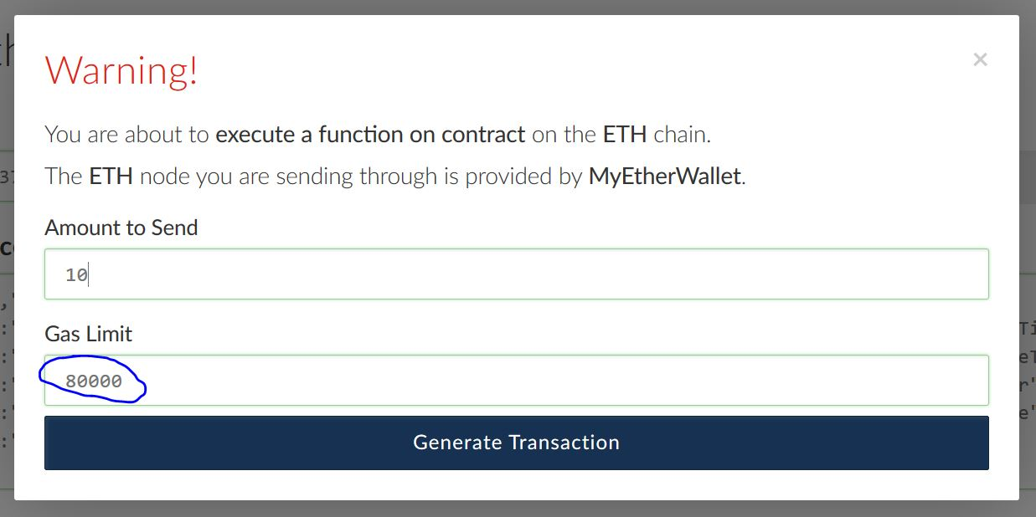

To exchange Ether for VERI tokens you simply have to send the amount of Ether you wish to convert to VERI tokens, to the TokenPurchase smart contract. The smart contract will automatically allocate your tokens to your Ethereum address.

Increase the Gas Limit to about 80,000 and Click **Generate Transaction**

|  |
| --- |
| **Congratulations**, you now have **VERI tokens**! |

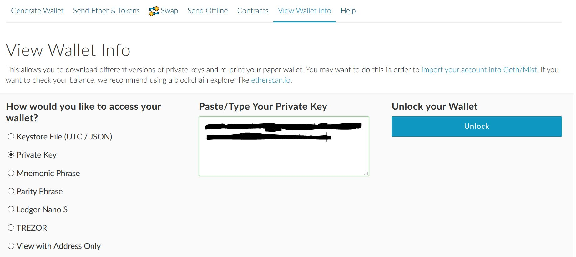

Next you will want to go to your Ethereum account and see your VERI tokens. Click on the **View Wallet Info** tab and enter your private key again, if the site asks you for it.

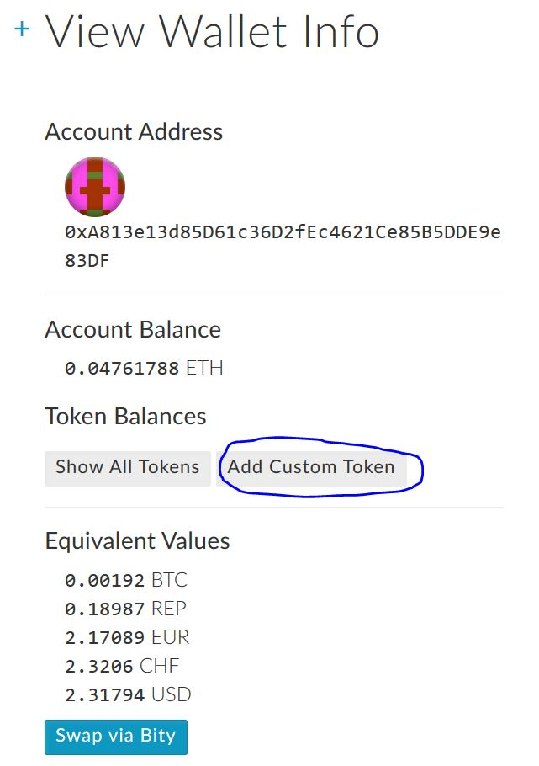

Click **Add Custom Token** and enter the address (**0x8f3470a7388c05ee4e7af3d01d8c722b0ff52374**) of VeritaseumToken into the Address box, **VERI** into the Token Symbol box, and **18** into the Decimals box and **Save**

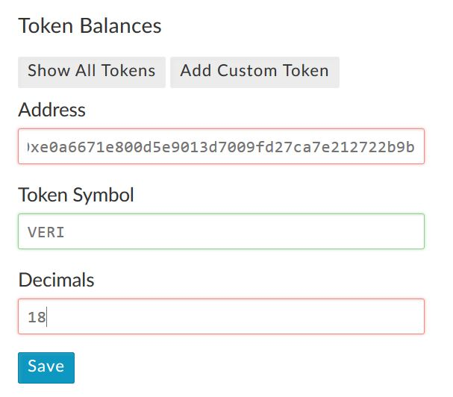

You will no be able to see VERI tokens for any and each Ethereum account that you may have.

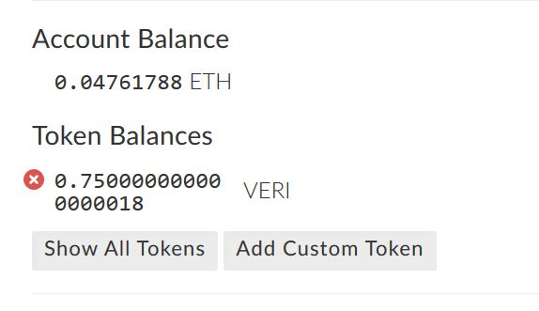

## Use VeritaseumToken smart contract and Tokens

Once you have Veritaseum Tokens you can do several things with it. Since this is an ERC20 compliant token you can basically exchange VERI tokens on any Ethereum exchange, and there are several. You can exchange them for other tokens, or sell them back to Ether at a later stage.

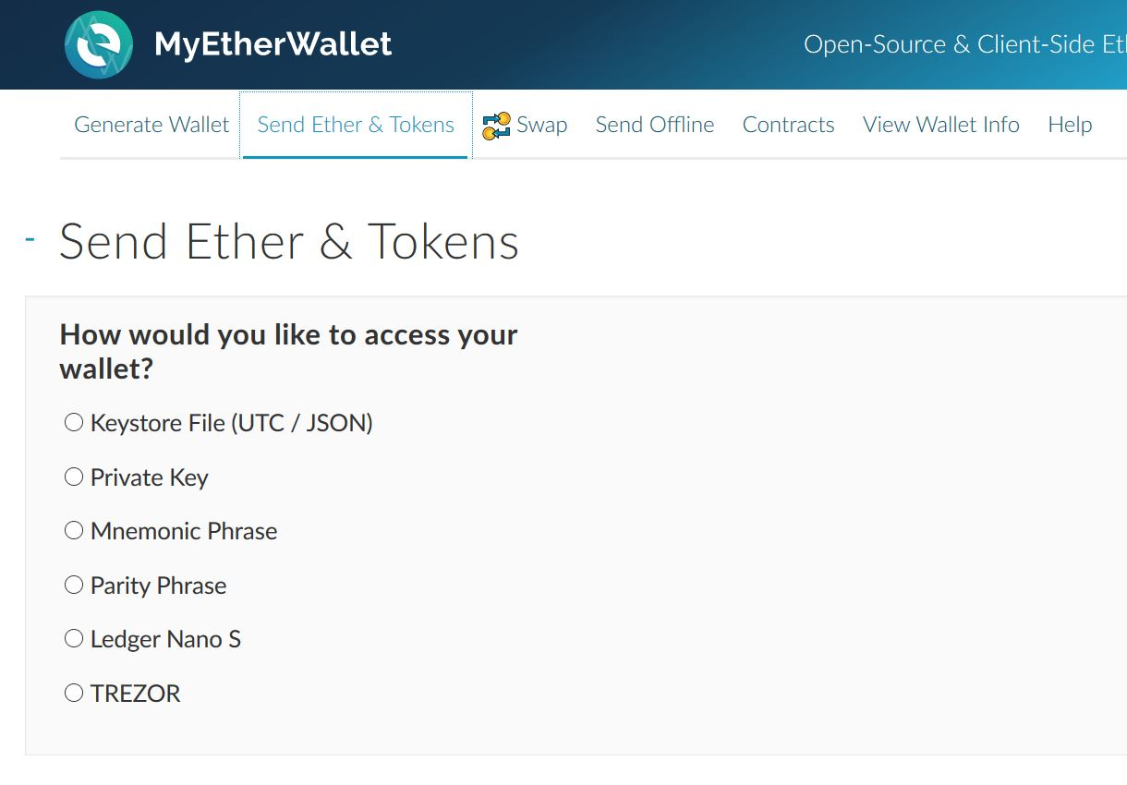

To use them on MyEtherWallet, click on **Send Ether & Tokens** tab. Enter your private key and Unlock.

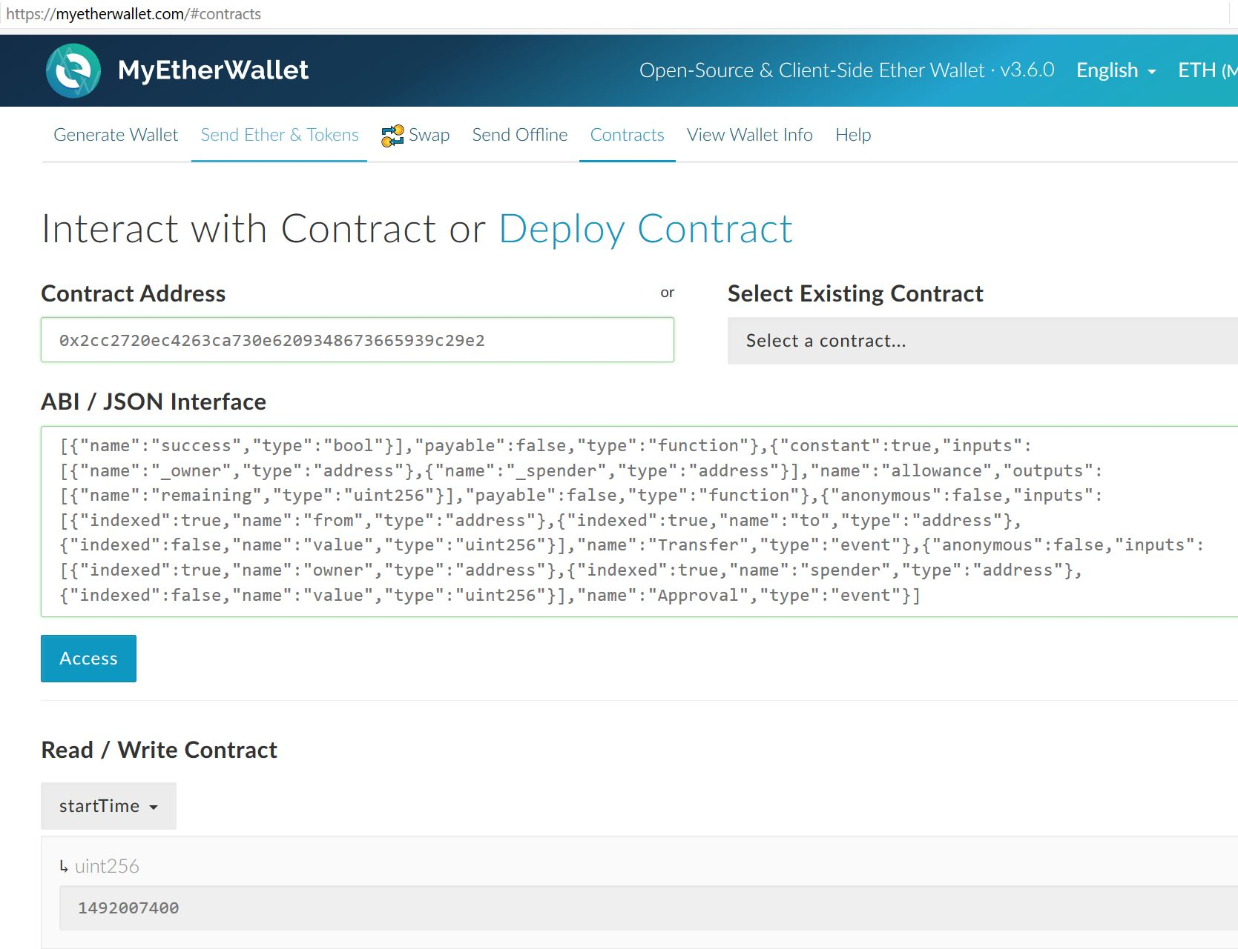

Now, enter the address (**0x8f3470a7388c05ee4e7af3d01d8c722b0ff52374**) of VeritaseumToken into the Contract Address box.

**Copy and paste** the VeritaseumToken ABI code from the box below.

click **Access**

|  |
| --- |
| [{"constant":true,"inputs":[],"name":"name","outputs":[{"name":"","type":"string"}],"payable":false,"type":"function"},{"constant":false,"inputs":[{"name":"_spender","type":"address"},{"name":"_value","type":"uint256"}],"name":"approve","outputs":[{"name":"success","type":"bool"}],"payable":false,"type":"function"},{"constant":true,"inputs":[],"name":"totalSupply","outputs":[{"name":"","type":"uint256"}],"payable":false,"type":"function"},{"constant":false,"inputs":[{"name":"_from","type":"address"},{"name":"_to","type":"address"},{"name":"_value","type":"uint256"}],"name":"transferFrom","outputs":[{"name":"success","type":"bool"}],"payable":false,"type":"function"},{"constant":true,"inputs":[],"name":"decimals","outputs":[{"name":"","type":"uint256"}],"payable":false,"type":"function"},{"constant":true,"inputs":[{"name":"_owner","type":"address"}],"name":"balanceOf","outputs":[{"name":"balance","type":"uint256"}],"payable":false,"type":"function"},{"constant":true,"inputs":[],"name":"owner","outputs":[{"name":"","type":"address"}],"payable":false,"type":"function"},{"constant":true,"inputs":[],"name":"symbol","outputs":[{"name":"","type":"string"}],"payable":false,"type":"function"},{"constant":false,"inputs":[{"name":"_to","type":"address"},{"name":"_value","type":"uint256"}],"name":"transfer","outputs":[{"name":"success","type":"bool"}],"payable":false,"type":"function"},{"constant":true,"inputs":[{"name":"_owner","type":"address"},{"name":"_spender","type":"address"}],"name":"allowance","outputs":[{"name":"remaining","type":"uint256"}],"payable":false,"type":"function"},{"inputs":[],"payable":false,"type":"constructor"},{"anonymous":false,"inputs":[{"indexed":true,"name":"from","type":"address"},{"indexed":true,"name":"to","type":"address"},{"indexed":false,"name":"value","type":"uint256"}],"name":"Transfer","type":"event"},{"anonymous":false,"inputs":[{"indexed":true,"name":"owner","type":"address"},{"indexed":true,"name":"spender","type":"address"},{"indexed":false,"name":"value","type":"uint256"}],"name":"Approval","type":"event"}] |

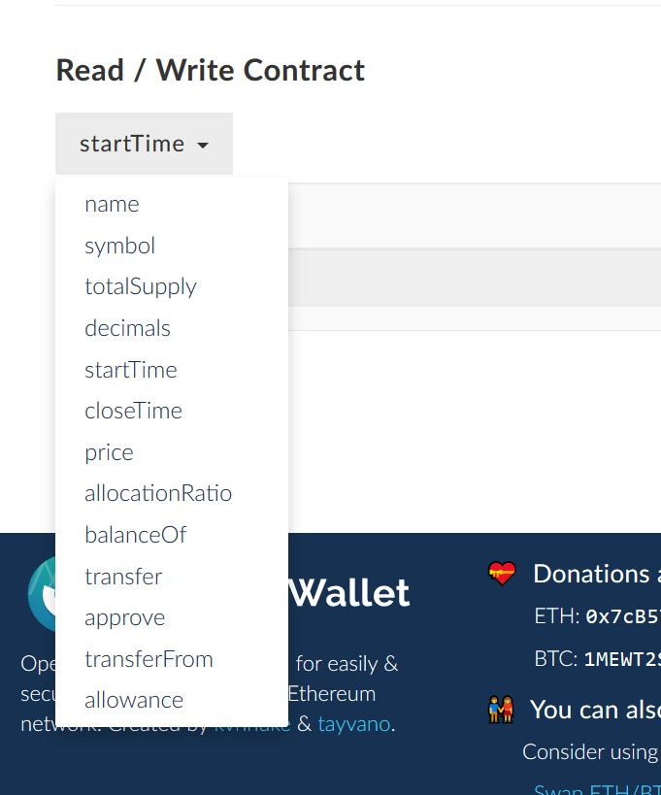

Now you can access all the public functions that this smart contract has. For more information about ERC20 complaint Tokens goto to [ERC20](https://github.com/ethereum/EIPs/issues/20)

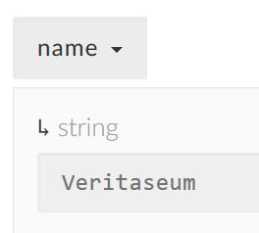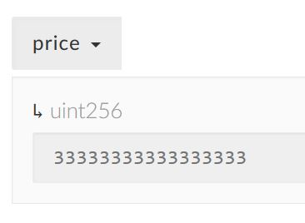 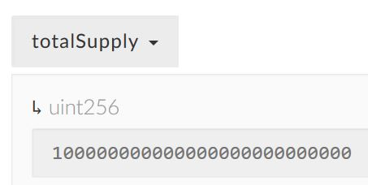

If you select price you can see that it has a lot of digits. Ethereum has high precision and uses 18 decimal standard precision.

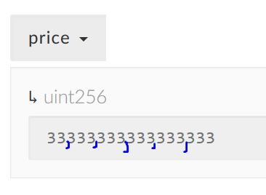

The cost of this token is 0.033,333,333,333,333,333 Ether per one token. OR 1 Ether is 30 tokens.

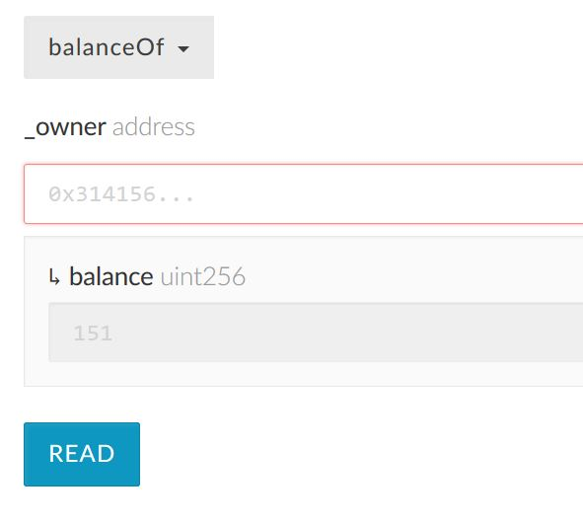

The function shows you how many tokens your account has.

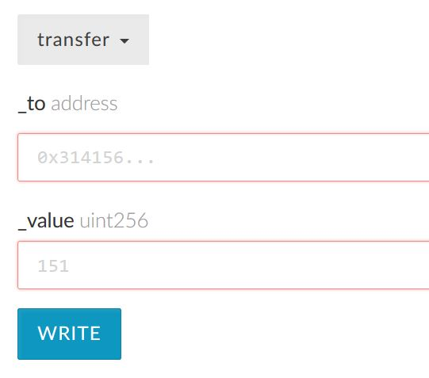

This function allows you to transfer your tokens to another Ethereum address, like your friends.

## Conclusion

Using Veritaseum Tokens are fun and easy. If you need more information about Ethereum Tokens, just Google it.